Project Documentation

1.Introduction

* Project Title: Your personal fitness companion
* **Team ID:** NM2025tmid2989
* **Team Leader:** SELVA VARSHINI S
* **Leader Mail ID**: [202400324@sigc.edu](mailto:202400324@sigc.edu)
* **Team Members:**
* **PRAGATHI S** - [202400278@sigc.edu](mailto:202400278@sigc.edu)
* **POOVIZHI S** - [202400269@sigc.edu](mailto:202400269@sigc.edu)
* **POORNASOWNDARYA V** - [202400225@sigc.edu](mailto:202400225@sigc.edu)

**2. Project Overview**

Purpose: To assist users in managing fitness routines, workout schedules, and personal progress.

Key Features:

- User authentication and profile management

- Fitness goal setting

- Workout tracking and history

- Nutrition and diet recommendations

- Dashboard for progress visualization

- Admin panel for content and user management

**3. System Architecture**

Frontend: React.js (Bootstrap + Material UI)

Backend: Node.js with Express.js

Database: MongoDB

Authentication: JWT-based secure login

**4. Setup Instructions**

Prerequisites:

- Node.js (LTS version)

- MongoDB

- Git

- Visual Studio Code

Installation Steps:

1. Clone repository: git clone

2. Install client dependencies: cd client && npm install

3. Install server dependencies: cd ../server && npm install

4. Start the application:

- Frontend: cd client && npm start

- Backend: cd server && npm start

5. Open in browser: http://localhost:3000

**5. Folder Structure**

FitFlex/

n client/ # React frontend

n n components/

n n pages/

n server/ # Node.js backend

n n routes/

n n models/

n n controllers/

n README.md

**6. API Documentation**

User:

- POST /api/user/register → Register new user

- POST /api/user/login → User login

Projects/Workouts:

- POST /api/projects/create → Create workout plan

- GET /api/projects/:id → Get workout details

Applications:

- POST /api/apply → Apply for challenge

Chats/Community:

- POST /api/chat/send

- GET /api/chat/:userId

**7. User Interface**

- Landing Page

- User Dashboard (fitness stats, progress)

- Workout/Project Details Page

- Admin Panel

**8. Testing**

- Manual testing at key milestones

- Tools: Postman, Chrome DevTools

**9. Future Enhancements**

- AI-based workout recommendations

- Wearable device integration (Fitbit, Apple Watch)

- Community forum for fitness discussions

- Gamification (rewards, streaks)

**10.Screenshot :**

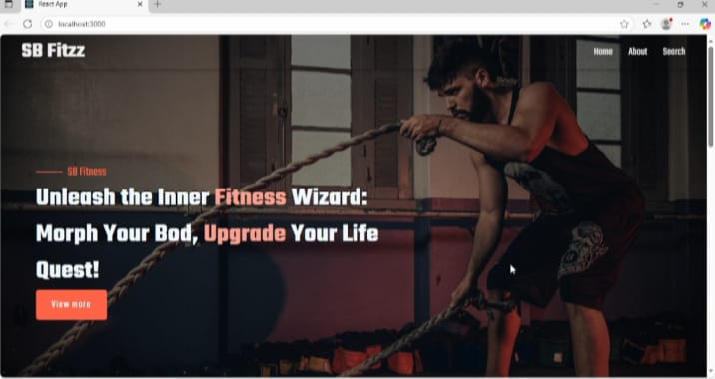

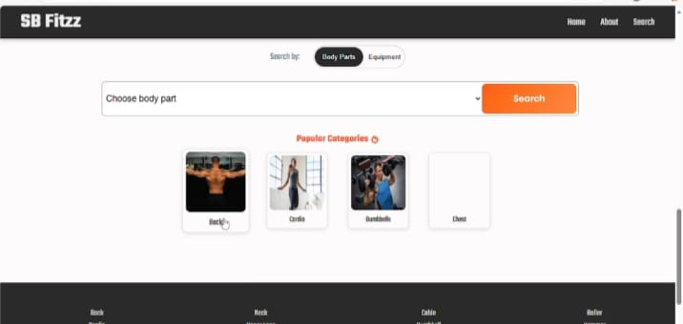

11.Demo link:

<https://drive.google.com/file/d/1IB8eP-AZSq1s8HnS4gZpRgK9fZNHa5Pm/view?usp=drivesdk>

12. Known Issues

· On slow networks, the exercise list might load before images, causing a layout shift.

· The workout timer feature occasionally does not reset correctly when navigating away mid-workout.

13. Future Enhancements

· Social features: Ability to share workouts and follow friends.

· Integration with wearable devices for automatic activity tracking.

· Advanced data visualization for progress tracking (charts/graphs).